**APP BUGS SHEET**

**Rahil Khan**

1. Referral amount not showing up even after making the first investment.

**Himantika Yadav**

1. Password not changed
2. Icon color change
3. For each investment plan chosen by the user, add a dropdown for each plan rather than showing it whole in tabular form
4. 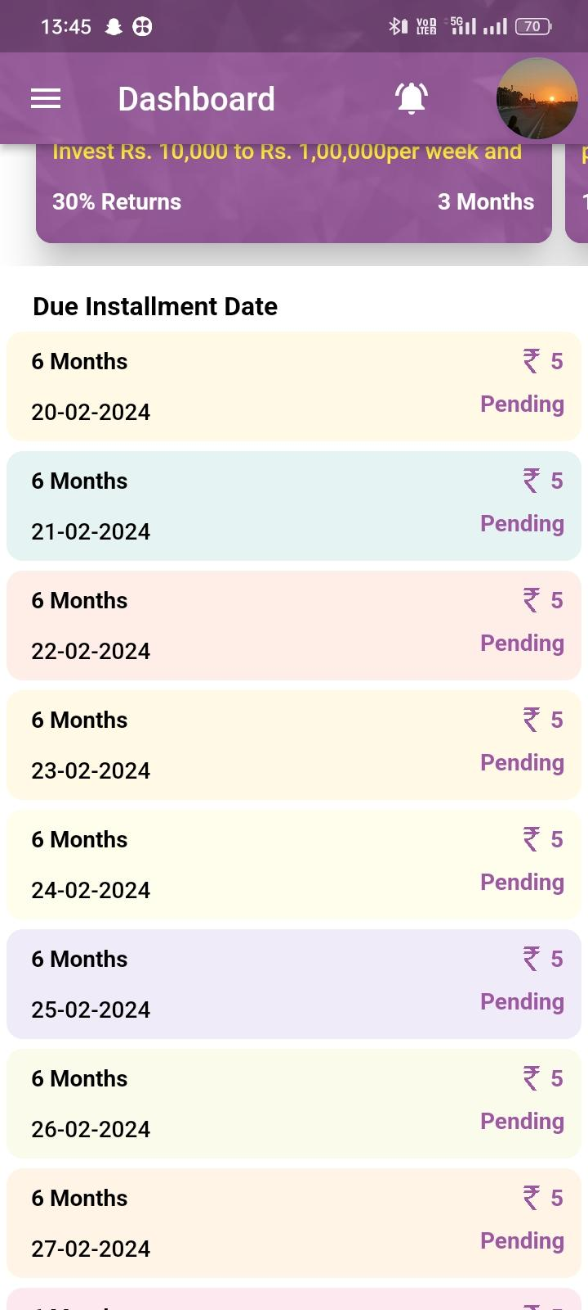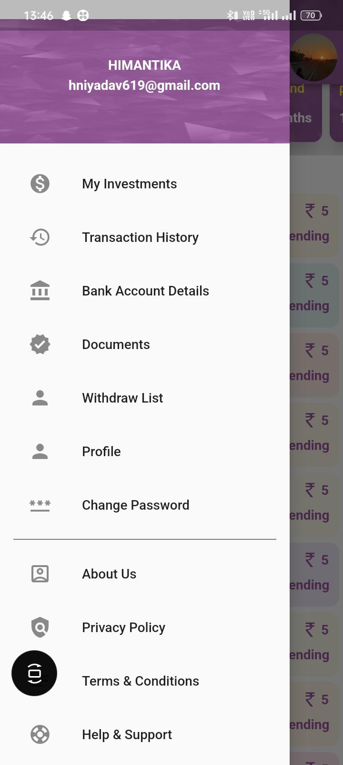

**Shilpi**

1.) Changing passwords is not working properly. It is directly

changing the password.

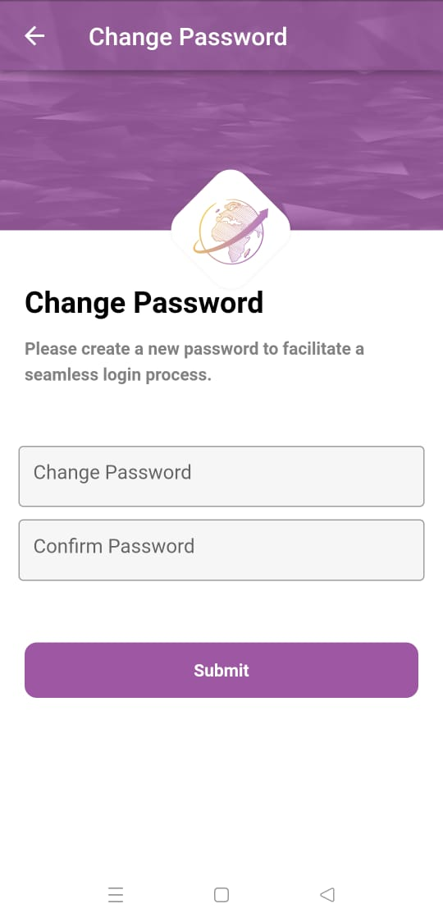

2.) The Withdrawal icon should be different.

3.) Investment plans should be scrolled automatically.

4.) Whatsapp support should be changed.

**Amit Gusain**

1. I can’t view my document, the view button opens and adds a new document option.
2. Invest Now button is not working
3. In the profile photo section. It shows document photos instead of profile Image.
4. Changing passwords was not asking for an old password first, they directly asked for a new password. So, they can have a major impact on security.
5. Investment plan carousel should be in an infinite loop.
6. Without debit the withdrawal request successfully sent and approved.

**Abhishek Ross**

**Niraj**

**Anamika**

**Nitisha**

**Sahil**

**Ritik**